**Hands-on AI and Machine Learning workshop**

**Department of Computer Science**

***Part B: Training a model using Python***

**STEP 4. Training a model ourselves using Python. 使用Python訓練一個模型**.

1. Download the **Part B Files** from the webpage and decompress it to **Local Disk (D:).**

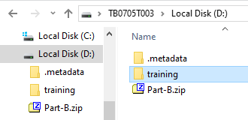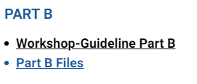

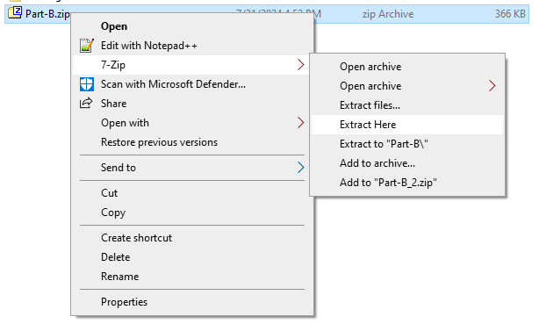Another way to decompress, **right click** it and click **7-Zip à** **Extract Here**.

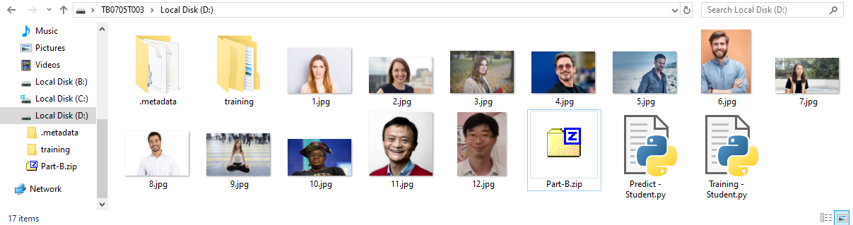Your folder should now look like the following:

1. There should be two python program files:

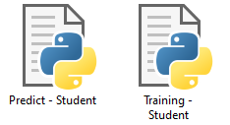

1. Right click on the train file, **Training - Student**, select **Edit with Notepad++.**

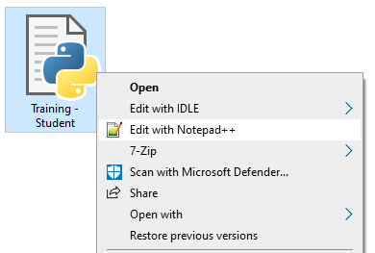

1. **\*Task A* Editing Model File Name.**

Go to the line (approximately line 51) and change **Student** to your name.

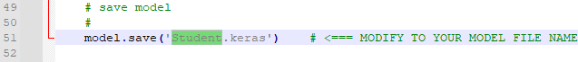E.g., Student **à** CHAN Tai Man

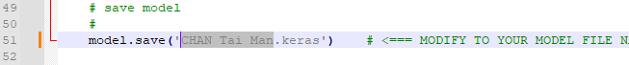Example result show:

1. Save your file as a new file, **File à** **Save As...**, name your file as **Training – your name,** e.g., Training – CHAN Tai Man, then click **Save**.

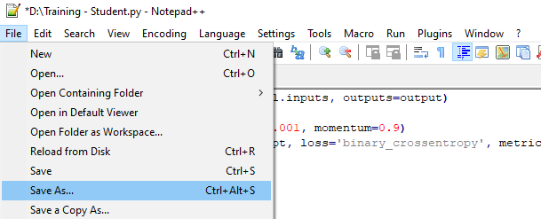

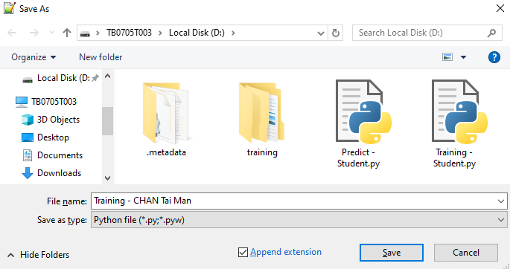

1. Look at **Local Disk (D:)**, a new python file appears, **double click** it (and click **OK** if asked to do so.)

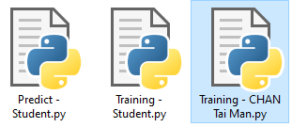

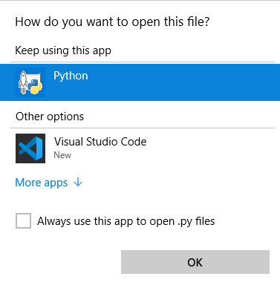

1. The following will appear. If successful, it will start to show the model training progress after a while.

Note that it will take some times to complete. What is the final accuracy of the model?

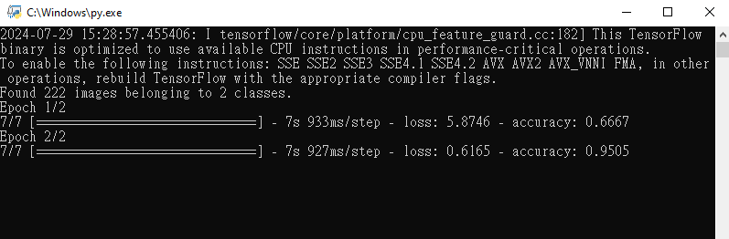

Note: your results could be different because Python uses a random algorithm when training, but the accuracy should be higher than 0.8. If your results are not ideal, you can try running a few more times (close the windows and double click your training file again).

* 1. *Optional step.*

Try to change the epoch and observe the final accuracy.

e.g., epochs = 1; epochs = 2; epochs = 3.

The original one is:

Try the following two cases.

Station 1:

 Station 2:

* 1. Check the **Local Disk (D:)**, the **CHAN Tai Man.keras** appeared**.**

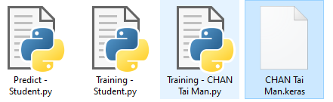

**STEP 5. Using the model to predict gender使用模型預測性別**

1. In **Local Disk (D:)**, right click on the predict file, **Predict - Student**, select **Edit with Notepad++.**

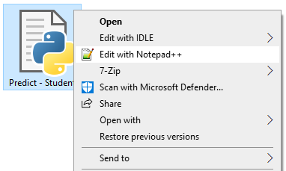

1. **\*TASK B\***

Go to the line (approximately line 30) and modify it to your model file name.

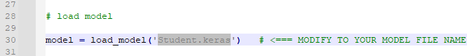

For example:



1. Save the predict file as a new file, **File à** **Save As...**, name your file as **Predict – your name,** e.g., Predict – CHAN Tai Man, then pause **Save**.

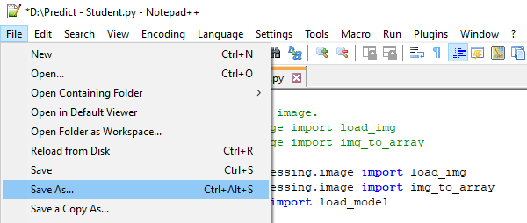

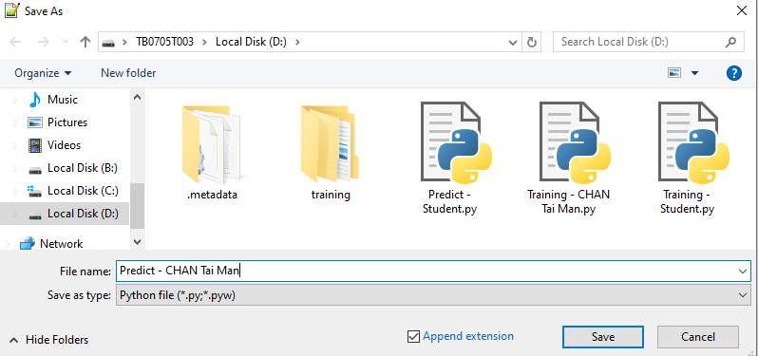

1. 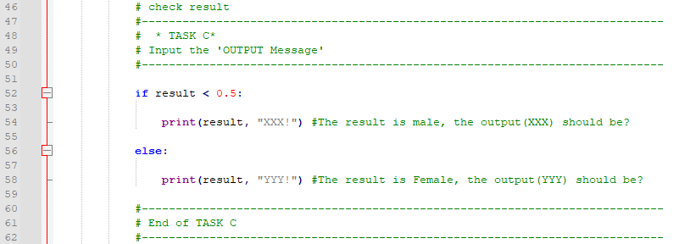**\*TASK C\***

Look for the part that says Task C, **replace “XXX!” by “Man!”** and **replace “YYY!” with “Woman!”** and save again.

a. *Optional step.*

- Try change **“Man!”** to **“Oh, the person in the images is Male.”**

- Try change **“Woman!”** to **“What a beautiful Lady!”**

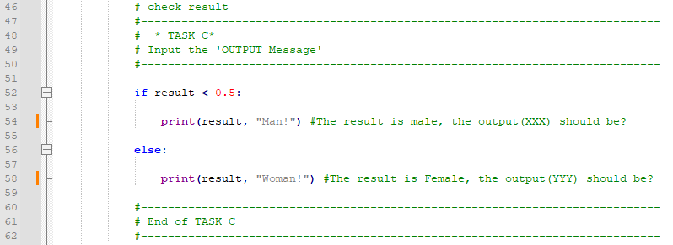**b. Reference.**

1. Returning to the Local Disk (D:), a new python file appears, double click to run and use it to predict.

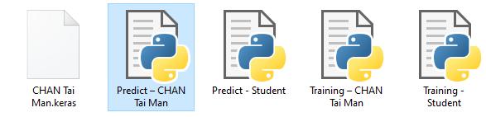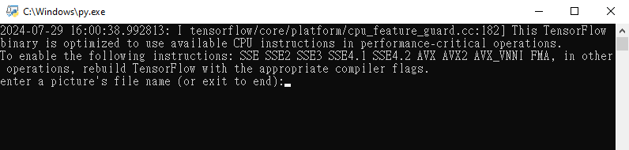

1. Based on the photo file names printed on the next page, try to predict the person in the picture is whether Man or Woman.

e.g., Enter **1.jpg** as the file name and press **Enter**.



You will see the answer (man or woman) from the AI model, it is correct?

1. Repeat this step for the remaining images. How many of them are correct? Which ones are wrong? Note them down and discuss them with your fellow students.

**Reference: Images file names for testing.**

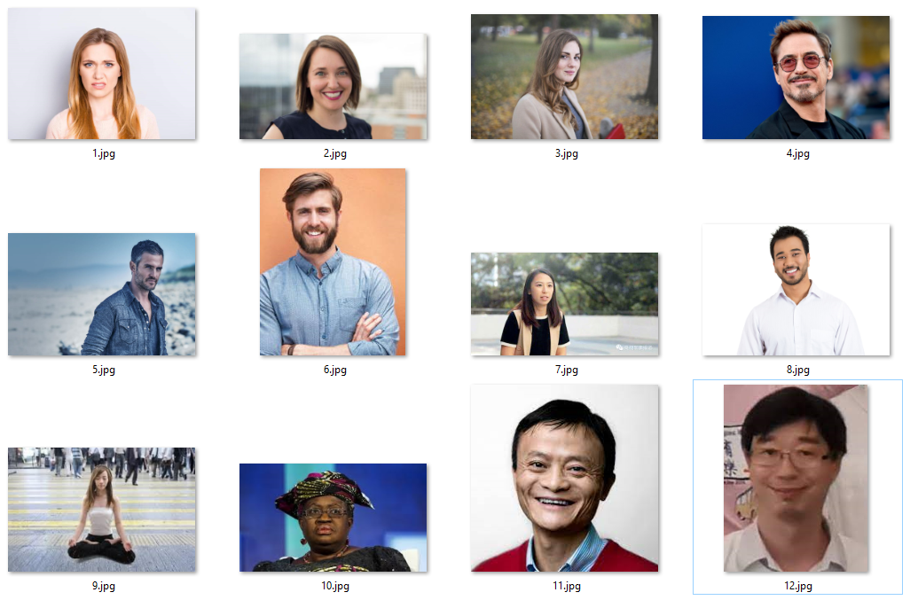

Reference 2.

Which ones are correctly identified by your model?

**How can we lower the prediction errors?**