**Hands-on AI and Machine Learning workshop**

**Department of Computer Science**

*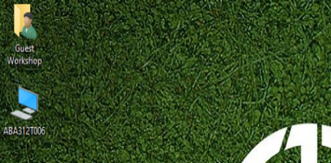****Part A: Training a model using an online tool (Teachable Machine)***

**STEP 1: Preparing the data (image files) 準備資料 (圖片檔案)**

1. On your Windows Desktop, click on the name of your computer on the upper left corner.
2. Graphical user interface, application

   Description automatically generatedGo to  **Local Disk (D:)**.
3. 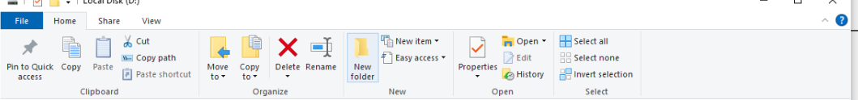Press **Control -F1** on your keyboard. The following menu will appear.
4. 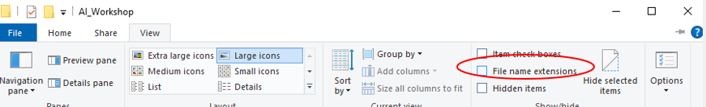Enable “File name extensions”, select **Large icons** (click it).
5. On your D: drive, create a new folder named **training.**

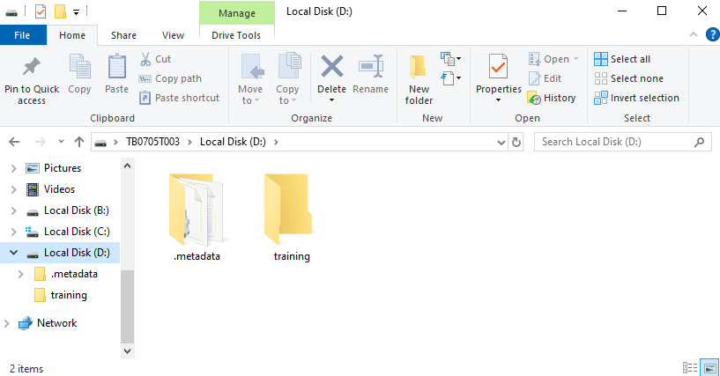

Open a browser (e.g., Chrome), and go to our **Workshop Webpage** <https://cs.hsu.edu.hk/workshop/>

Under the **Female and Male Images** session, **right click** on **female.** Save the compressed file into the *training* folder that you have created above.



1. On Windows, double click on the compressed file you have downloaded. The following will appear.

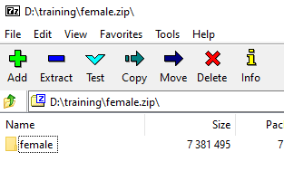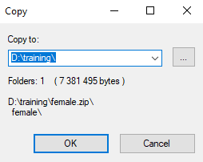Click **Extract.** You should have a folder of female images.

1. 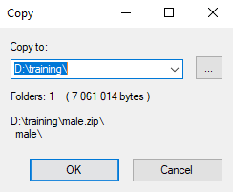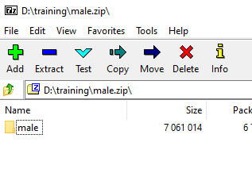Repeat steps 5 and 6 for the **male** files.
2. 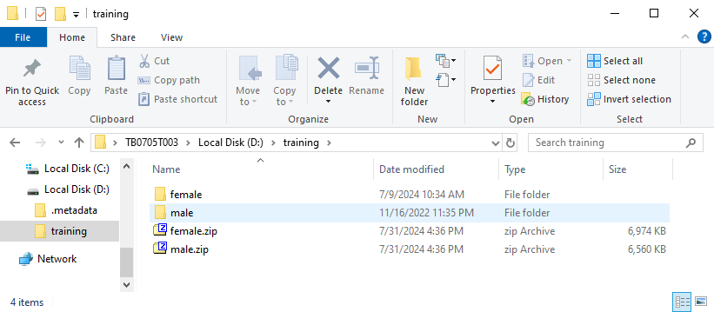Your *training* folder should look like this

**STEP 2: Train a Model online 網上訓練一個模型**

1. Return to our **Workshop Webpage**.

<https://cs.hsu.edu.hk/workshop/>

1. Click on **Machine Learning with Teachable Machine**

1. Select **Image Project** on the Teachable Machine Website

1. Select **Standard image model**
2. A screenshot of a computer

   Description automatically generatedChange the two class labels to **Female** and **Male** respectively
3. Graphical user interface, text, application, Teams

   Description automatically generatedIn the **Female** category, choose **Upload**
4. A collage of images of women

   Description automatically generated Go to your **Female** folder on **Windows**. Select (drag) around 50 to 100 female photos to the **Choose images from your files label.** Those images should then appear on the website. (Note: do not use all images. Leave a few for later steps).

1. Repeat steps 14 and 15 for the **male** images.
2. Select **Training model** on the Teachable Machine page. Note that this may take a few minutes. Do not leave this page.

**STEP 3: Testing the Model 測試模型**

1. After the model is ready. Select **File** in the **Preview** area. Make sure **Input** is **ON**.
2. Drag some of the remaining female/male photos to the model to test it. Are the outputs correct? You may also try to test it with other photos if you like.

**